Registering for Digital Order Card
Parents/Girls Under 13


Watch for your registration email* from “Girl Scout Cookies” (email@email.girlscouts.org) with the subject “Register for the Digital Cookie Platform Today”. Your council will let you know the approximate date you can expect to see that email. Search your “Promotions/Clutter/Spam” folder too.

*If you did not receive a registration email, see the “No Registration Email” Tip Sheet.

Be sure to add email@email.girlscouts.org to your address book so you get your email!

Click: Green “Register Now”


In the email is a green button to take you to the Digital Order Card registration site. Simply click that button!
(For best results, use the most recent version of your web browser)


Once you click the link you’ll be on the Digital Order Card 6.0 site.
You’ll need to create a password.

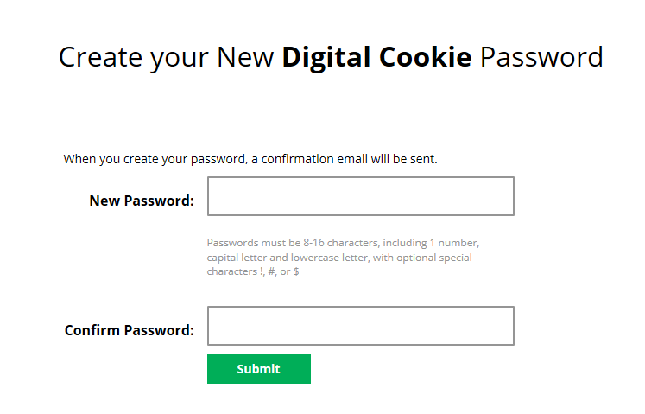


Use your new password to log in. Remember to use the same email address where you received your registration email-that’s the one your Girl Scout Council has on file for you.

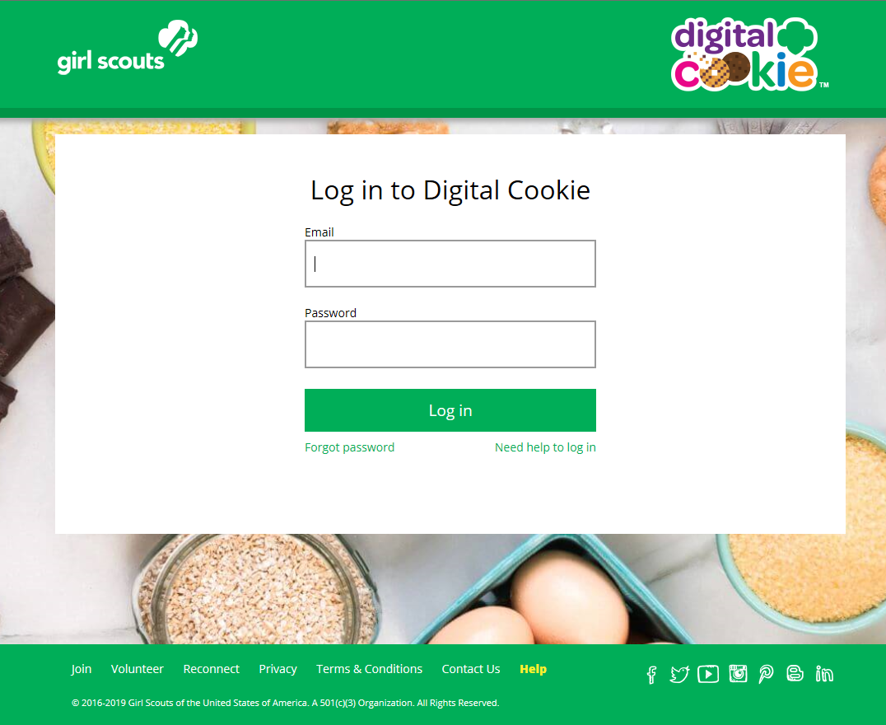


When you first log in, you will have the “Safe Selling for Smart Cookies” safety video pop-up to watch and review with your Girl Scout(s).
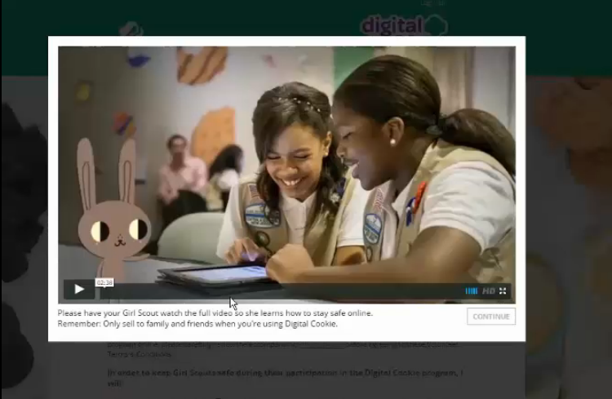
You can’t proceed any further until the full video has been viewed.


Read and accept the Terms and Conditions agreement. Note, if you are a volunteer, you will first see an additional Terms and Conditions for Volunteers.
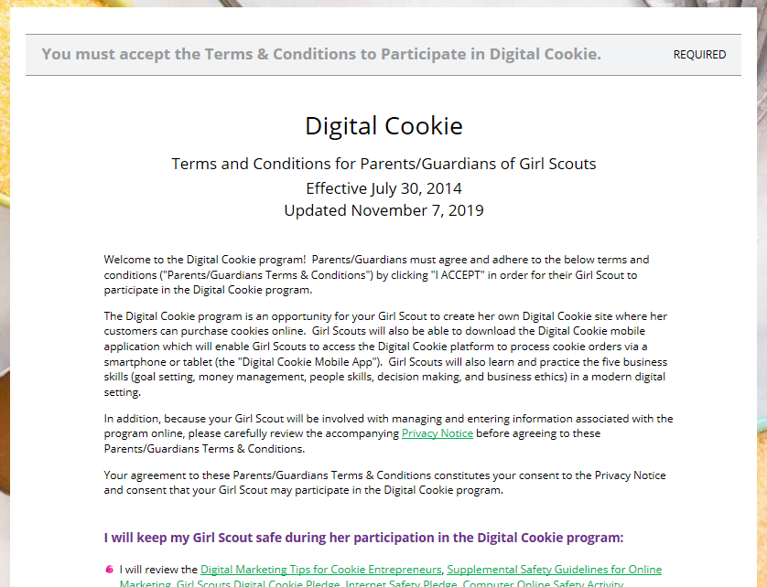
Check box to accept
Continue
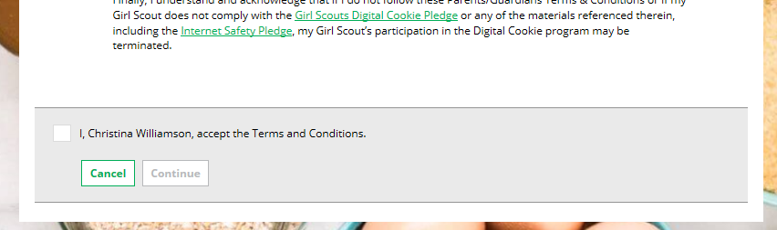


Next, the “Girl Scout Safety Pledge” will appear. Be sure to read it to/with your Girl Scout(s). Then check the box for “accept” and click “continue.”

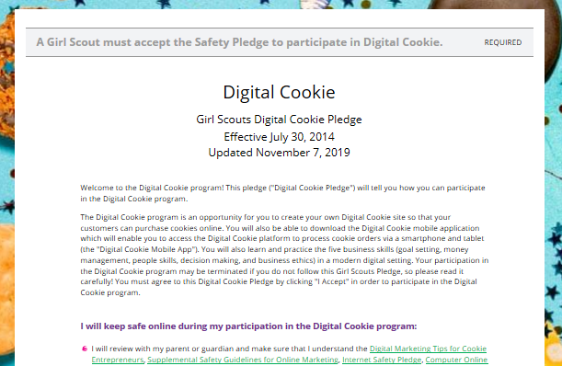
Check box to accept.
Continue
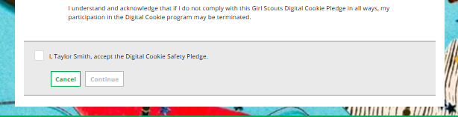

You will then be taken to a screen to register your girl or girls for the Digital Cookie program.
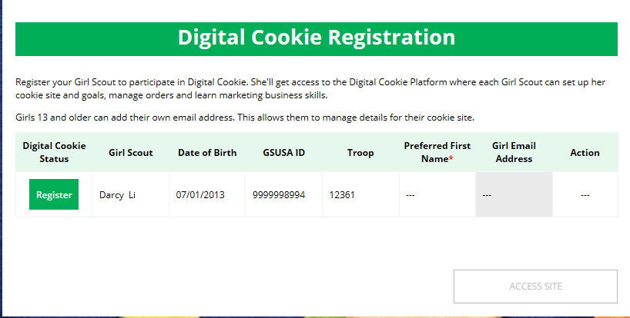
Click to register girls

If the Girl Scout you are registering is 13 or older, you can enter her email address and she will complete her own registration process. (See “Site Registration--Girl 13 and Older” Tip Sheet for instructions.) Girls under 13 will login in partnership with her caregiver.
After registering all your girls (if you have multiple girls), you will click the “Access Site” button to be taken to the first girl’s home page.

Once you have registered, watch your inbox for a registration confirmation email and save this email where you can find it during cookie season!

Next Steps: Site Setup
Marketing to Customers

Other useful trainings: Earning Badges
Accessing the Games/Videos

